
Exhibitor documentation
Set-up, exhibition and dismantling times

Own stand construction
From Monday 23 March 2026 8 a.m. – 9 p.m.
Set-up System stands / shared stands / workspace
From Tuesday, 24 March 2026 8:00 a.m. – 8:00 p.m.
Wednesday 25 March 2026 8:00 a.m. – 9:30 a.m.
Start/end of trade fair: Wednesday 25 March 2026 10:00 a.m. – 6:00 p.m.
Thursday 26 March 2026 10:00 a.m. – 6:00 p.m.
Friday 27 March 2026 10:00 a.m. – 5:00 p.m.

Dismantling: System stands / shared stands / workshop area
Friday 27 March 2026 5:05 p.m. – 8:00 p.m.

Own stand construction
until Saturday 28 March 2026 8:00 a.m. – 12:00 p.m.
System stands and the work area must be cleared by 8:00 p.m. on Friday. Exceptions may be made after consultation with the exhibition management. Please note that the stand areas must be cleared by 12:00 noon on Saturday, 27 March.

Important: Vehicles may not remain on the event grounds after unloading.
Restricted times for deliveries by vehicle:
- During lunchtime from 11:30 a.m. to 1:30 p.m.
- in the evening from 8 p.m.
A DETAILED TRAFFIC PLAN WITH EXACT DELIVERY SLOTS FOR YOUR STAND CONSTRUCTION OR STAND FURNISHINGS WILL BE SENT TO YOU APPROXIMATELY 2 WEEKS BEFORE THE START OF THE FAIR.

Set-up and dismantling

Due to limited loading zones on the premises, a slot system with a maximum duration of 25 minutes per slot is required for goods handling. Please let us know your preferred delivery time via this LINK by 06.02.26. We will take this into account as far as possible.

Approximately two weeks before the start of the trade fair, you will receive a detailed traffic concept with assigned delivery slots and the access permit, which must be carried in the vehicle.

Site plan Hall 550

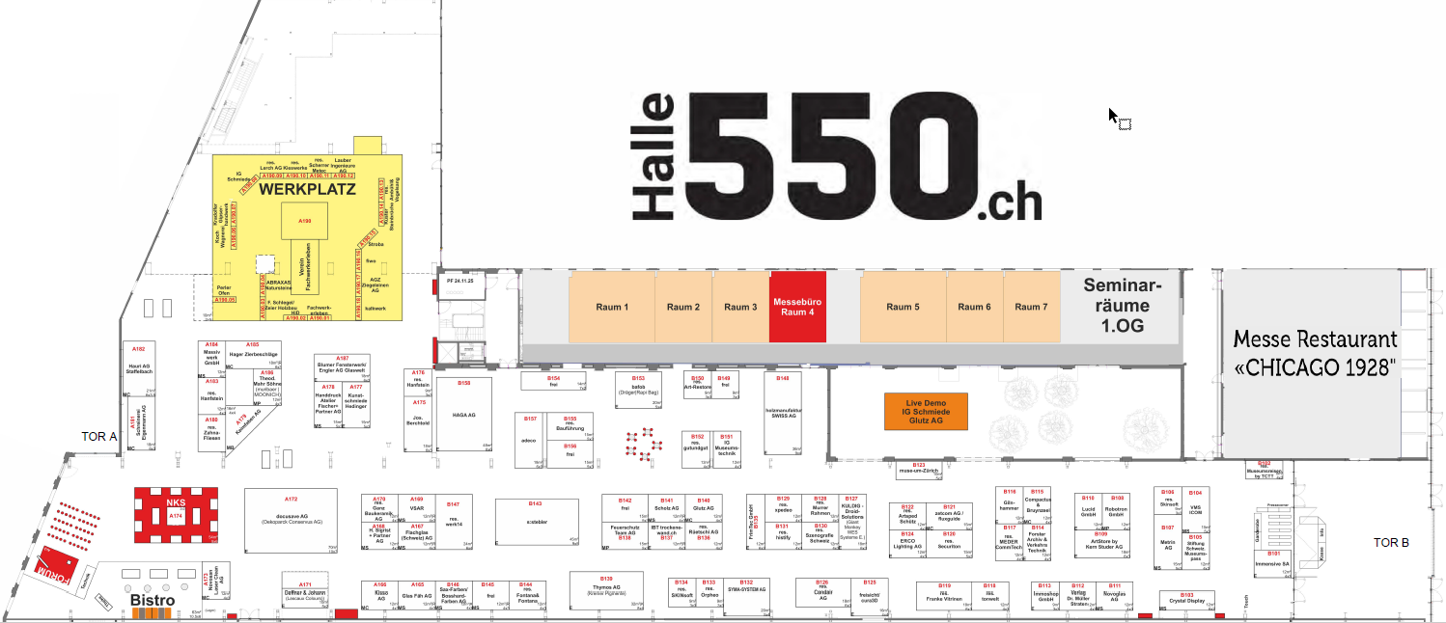

Location of the exhibition office

Hall 550, Room 4 (1st floor) / Tel. +41 41 201 89 91

Badges for exhibitors

You can collect your passes from the exhibition office during set-up. These must be worn during the exhibition and when entering the halls. It is not necessary to wear the passes during set-up.

Visitor tickets

Admission ticket:
Day tickets costing CHF 25 can be ordered in advance online via our website www.cultura-suisse.ch or from our ticket partner "TICKETINO", or purchased at the box office.
You have the option of offering your customers free admission tickets using your individual company code. Exhibitors will not be charged for these tickets. As an exhibitor, you even benefit from an incentive for each invited visitor. For further details, please refer to the supplementary sheet "Ticketing with promo code".

Delivery of brochures/small items by post (domestic deliveries only)

Hall 550
"CULTURA SUISSE
Exhibitor name / Stand no.
Birchstrasse 150
8050 Zurich
Deliveries can be made to us from Monday, 23 March 2026 at the earliest. We cannot guarantee acceptance before this date. The organiser and hall operator accept no liability.

Parking
Car parks
There are six different car parks around Hall 550. Please note the respective entrance height. Unfortunately, discounted entry and exit tickets are not available from the organiser.

No vehicles may be parked directly in front of or next to Hall 550, except in the designated loading zones during set-up and dismantling.

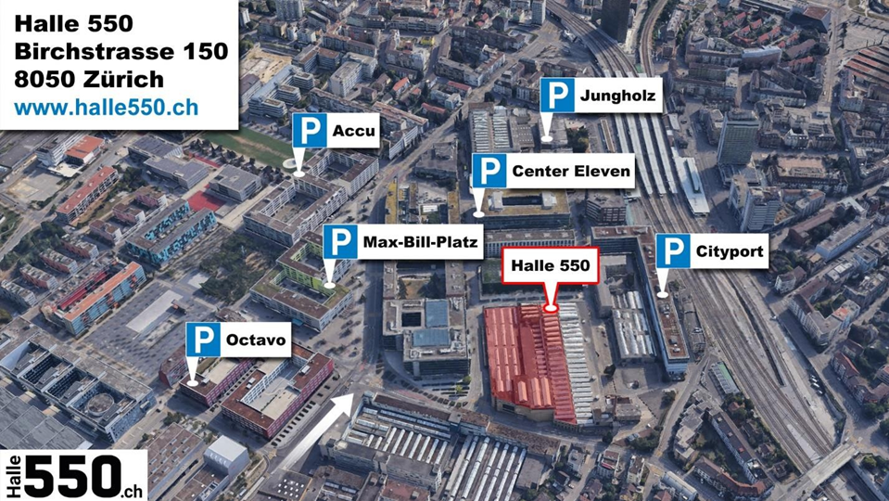

Car park | Address | Entrance height
Accu | Otto Schütz-Weg, 8050 Zurich | 1.90 m
Center Eleven | Sophie-Täuber-Strasse 4, 8050 Zurich | 2.00 m
Cityport | Affolternstrasse 56, 8050 Zurich | 2.05 m
Jungholz | Jungholzstrasse 19, 8050 Zurich | 2.20 m
Max Bill Square | Armin-Bollinger-Weg, 8050 Zurich | 2.30 m
Octavo | Brown Boveri-Strasse 2, 8050 Zurich | 2.10 m
The availability of parking spaces can be checked online via the parking guidance system:
http://www.pls-zh.ch/parkraum.jsp?prid=3

Hotel recommendations
See "Halle550_Factsheet_Hotelpartnerschaft_DE"

Wi-Fi
In addition to the free guest Wi-Fi in Hall 550, optional "CULTURA SUISSE" Wi-Fi is available throughout the exhibition grounds, accessible only to exhibitors. Access can be ordered using the respective order form for stand construction.

General information

Stand construction partner of the exhibition organiser
Partner of the trade fair organiser for stand construction

Stauffis Messebau AG
Aarauerstrasse 23, CH-5734 Reinach
+41 62 765 70 40
info@stauffis.ch | www.stauffis.ch

Lighting and sound technology / audio
Sons et lumières / audio

smARTec Veranstaltungstechnik AG
Elias-Canetti-Strasse 146, CH-8050 Zurich
062 888 19 19
info@smARTec.com | www.smartec.com

Assistance with customs clearance and transport
Assistance with customs clearance and transport

Z + L Customs and Logistics Ltd
Lehenmattstrasse 352, CH-4052 Basel
+41 061 313 42 02
info@zollundlogistik.ch | https://zollundlogistik.ch/

Addressing of exhibitor goods (All shipments are to be sent carriage paid to the destination)
Address for sending exhibition items (Please ship goods carriage paid to destination)
Hall 550
c/o CULTURA SUISSE
(Exhibitor)
(Stand no. / n° de stand)
Birchstrasse 150
CH-8050 Zurich

Catering (exhibition restaurant)

Chicago 1928 | Hall 550
Ricarda-Huch-Strasse, 8050 Zurich-Oerlikon
info@chicago1928.ch | www.chicago1928.ch

Technical advice before and during the event
Technical advice before and during the event

CULTURA SUISSE
c/o event-ex ag
Amtsstrasse 3, 8610 Uster
+41 41 201 90 70
info@cultura-suisse.ch

Information for stand construction

Standard height of stand fittings
In all halls, the height of stand installations may not exceed 5.00 metres from the hall floor. Upon written request, the exhibition management may grant exemptions for structures that exceed the regulatory standard height.

Suspensions/ceiling loads
Suspensions are hanging devices that are attached to the hall structure. Exhibitors are not permitted to attach parts of the stand structure, aids such as lights and lamps, or decorations to the hall structure. To ensure that the total weight of the suspensions does not exceed the load-bearing capacity of the hall structure and that the legal and insurance requirements are met, all suspensions must be ordered from the exhibition organiser. The organiser will provide a quote for the desired suspensions as soon as the necessary information is available in writing: plan of the stand concept, weight of the object, height of the object.

Hall floors/stand walls
In your own interest, please treat the hall floors and stand walls (if you have ordered a modular stand) with care. Defective material and the cost of removing adhesive tape etc. will be charged to the exhibitor. We therefore ask you to note the following:
- If you lay carpet, only Permafix 542 adhesive tape, which can be removed without leaving any residue, may be used. Appropriate rolls (30 mm x 25 m) are available from the exhibition office.
- The floor and walls must not be painted or marked.
- Please do not hammer/screw/drill nails or screws into the walls. Suitable fastening materials (power strips/screws) can be obtained from the exhibition office.
- Please remove all adhesive tape and fastening materials after the exhibition.

Please observe the operating regulations for Hall 550, which will be provided with the technical order forms.

CULTURA SUISSE
December 2025v1

